Week 9 Report

Recommendation System

37237256 薛丁銘

I did not do much in this week’s work. Just follow the contents taught in the class.

When I selected the movie, I chose to see the most popular and highly rated ones ahead. The code and the result are as shown in Figure 1.



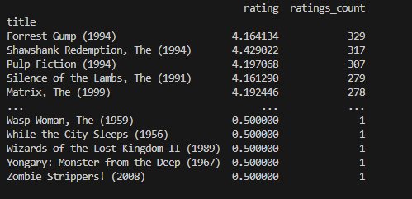

Figure 1. The most popular and highly rated movies

Great! The Matrix! That’s it! The recommendation code is as shown in Figure 2 and the result is as shown in Figure 3.

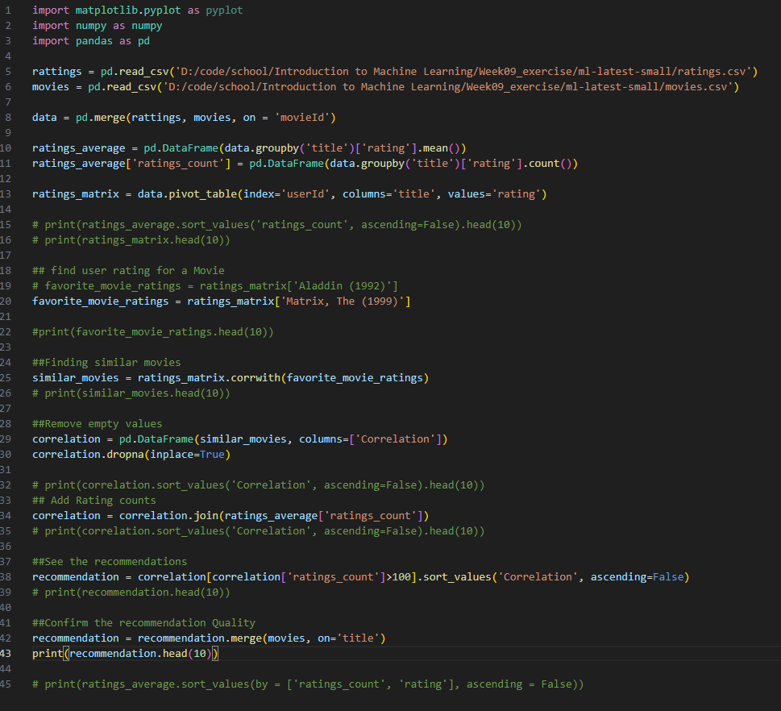

Figure 2. Recommendation code

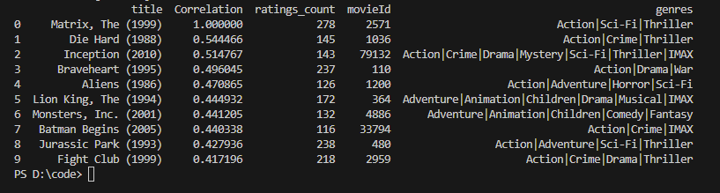

Figure 3. Recommendation results

So I would recommend ‘Die hard’, or ‘Inception’ is also a good choice.